## Enabling Diagnostics and Monitoring

### Lab Overview

In this lab, you will explore the diagnostics capabilities built into the Azure Virtual Machine platform.

You will configure the diagnostics agent, configure alerts, and review the boot diagnostics capabilities.

### Exercise 1: Review Boot Diagnostics

1. Within the Azure Management Portal, open the **WebVM-1** virtual machine. In the Settings blade click Boot diagnostics to view a screenshot of the console. Note that you can download the screenshot and see the date/time stamp on which it was taken. This can be useful for troubleshooting boot issues of your virtual machine.

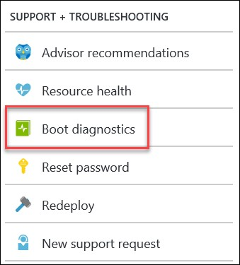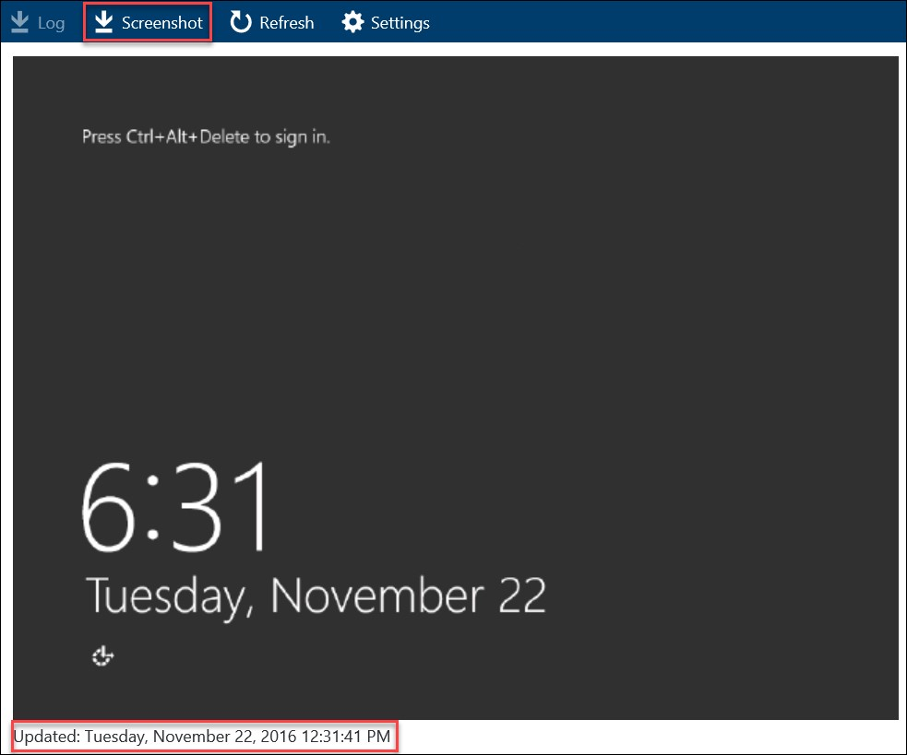

### Exercise 2: Configure an Alert

1. Within the Settings Blade for **WebVM-1** click **Alert Rules**.

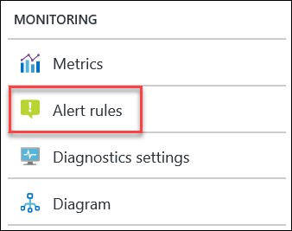

1. On the Alert rules blade click **Add metric alert**.



1. Specify the following configuration for the alert rule and click **OK**:
   1. **Name**: CPU Alert
   2. **Description**: Alert on High CPU Usage
   3. **Source**
      1. **Alert on**: Metrics
   4. **Criteria** 
      1. **Subscription**: Choose yours
      2. **Resource group**: OpsVMRmRG
      3. **Resource**: WebVM-1 iv. **Metric**: Percentage CPU
      4. **Condition**: Greater Than
      5. **Threshold**: 25
      6. **Period**: Over the last 5 minutes
   5. Notify via
      1. **Additional Administrator Emails**: specify your email address here to receive the notification.

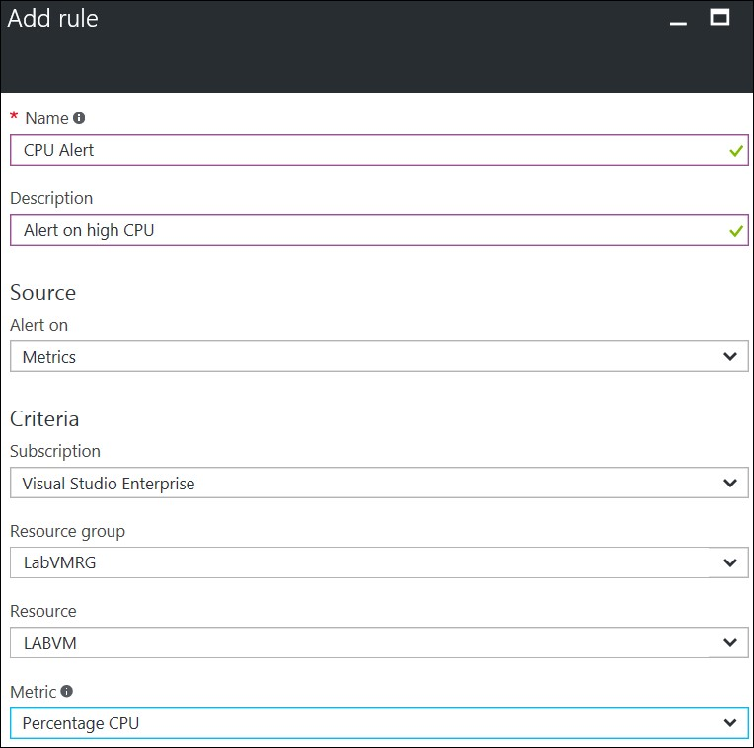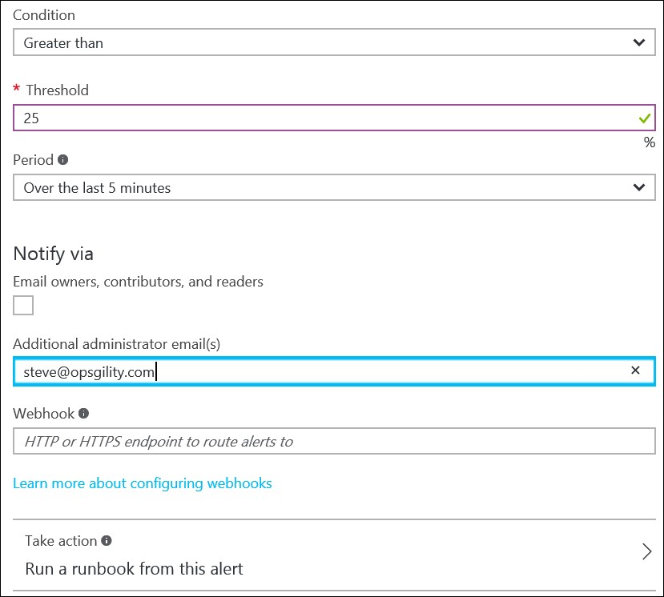

1. Navigate to the public IP address for **WebVM-1** where you should see the CloudShop web app.

1. Scroll down on the page to the CPU Spike Demo section. Change **Minutes** to **15** and click **Spike CPU**.

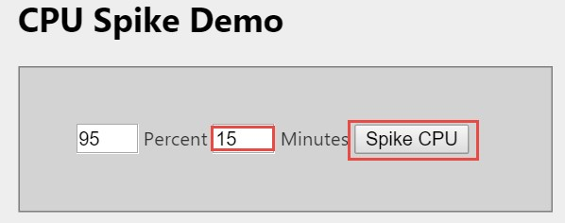

1. After 5-15 minutes you should receive an alert email notifying the alert was triggered. After a while you will receive a second noting that the issue has been resolved (after CPU usage drops).

|  |  |
| --- | --- |
| Alert notification email | Alert resolution email |

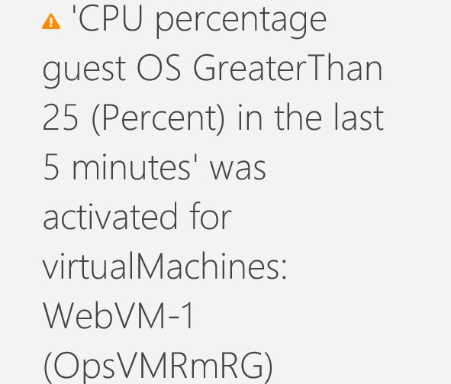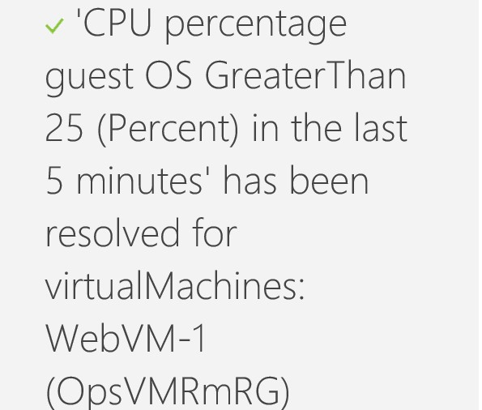

The monitoring tile should also show the increased CPU utilization:

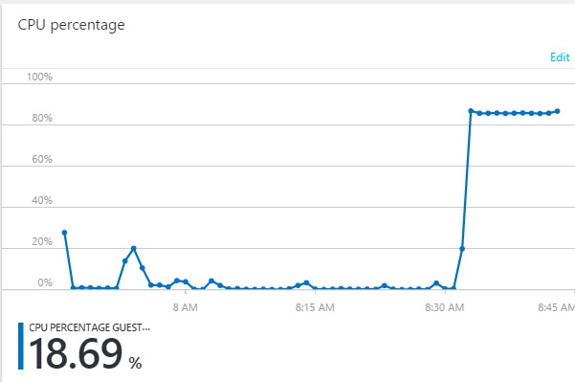

### Exercise 3: Configure Log Capture of IIS Logs

1. Within the Settings Blade for **WebVM-1** click **Diagnostics settings**.

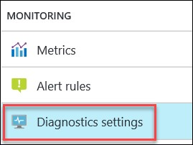

1. On the Diagnostics blade, under **Storage account** click on **Configure required settings** and click to select a storage account.

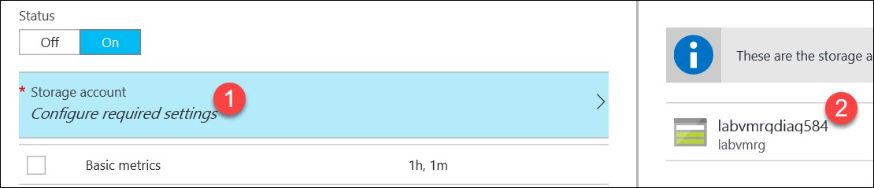

1. Check the boxes beside **Basic metrics**, **Network metrics**, **Windows event system logs** (level **Error**), **Windows event application logs** (level **All**), and **IIS**.Click the **Save** button on the toolbar.

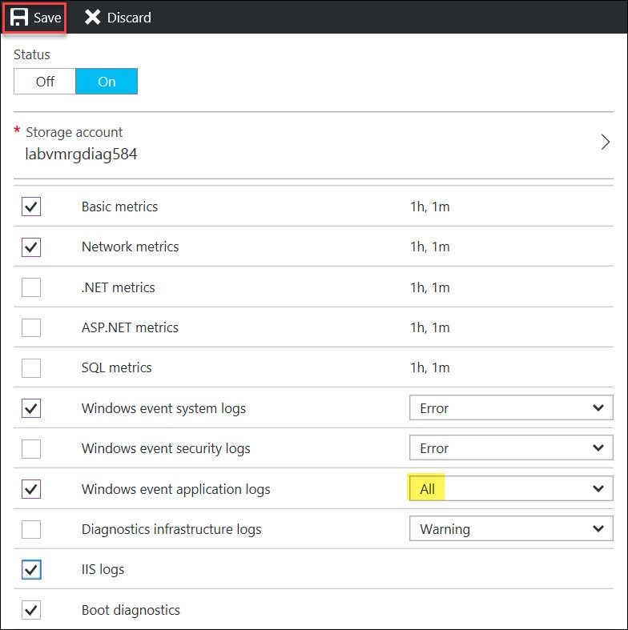

Tip: The Azure Management Portal can surface performance counter metrics, but to download data such as event logs and IIS log files tools such as PowerShell, Visual Studio, and 3rd party tools like Cerebrata Azure Management Studio must be used.

### Lab Summary

In this lab, you explored the diagnostics capabilities built into the Azure Virtual Machine platform. You configured the diagnostics agent, configured alerts, and reviewed the boot diagnostics capabilities.